Data set information
This dataset, compiled in 1988, encompasses information from four distinct databases: Cleveland, Hungary, Switzerland, and Long Beach V. Comprising 76 attributes, inclusive of the predicted attribute, the dataset has been predominantly utilized in published experiments focusing on a subset of 14 key features. The critical "target" field denotes the percentage of heart attack risk in patients

Attribute Information
AGE: age in years SEX: (1 = male; 0 = female)
CP (Chest Pain Type):
--Value 0: typical angina (most serious)
--Value 1: atypical angina
--Value 2: non-anginal pain
--Value 3: asymptomatic (least serious)
TRESTBPS: resting blood pressure (in mm Hg on admission to the hospital)
CHOL: serum cholesterol in mg/dl
FBS: (fasting blood sugar > 120 mg/dl) (1 = true; 0 = false) A fasting blood sugar level less than 100 mg/dL is normal. From 100 to 120 mg is considered prediabetes. If it is 125 mg/dL or higher on two separate tests, you have diabetes.
RESTECG (Resting Electrocardiographic Results):
--Value 0: normal
--Value 1: having ST-T wave abnormality (T wave inversions and/or ST elevation or depression of > 0.05 mV)
--Value 2: showing probable or definite left ventricular hypertrophy by Estes' criteria
THALACH: maximum heart rate achieved
EXANG: exercise induced angina (1 = yes; 0 = no)
OLDPEAK: ST depression induced by exercise relative to rest ('ST' relates to positions on the ECG plot. )
SLOPE: the slope of the peak exercise ST segment:

--Value 0: upsloping
--Value 1: flat
--Value 2: downsloping
CA: number of major vessels (0-3) colored by fluoroscopy
THAL: 3 = normal; 6 = fixed defect; 7 = reversible defect
TARGET: diagnosis of heart disease (angiographic disease status)
-- Value 0: < 50% diameter narrowing
-- Value 1: > 50% diameter narrowing

Load libraries
We load the necessary packages and set working directory.
rm(list=ls())
library(AER)
## Loading required package: car
## Loading required package: carData
## Loading required package: lmtest
## Loading required package: zoo
##
## Attaching package: 'zoo'
## The following objects are masked from 'package:base':
##
## as.Date, as.Date.numeric
## Loading required package: sandwich
## Warning: package 'sandwich' was built under R version 4.3.2
## Loading required package: survival
## Warning: package 'survival' was built under R version 4.3.2
library(car)
library(FactoMineR)
## Warning: package 'FactoMineR' was built under R version 4.3.2

Load data and take a look
file_path = "C:/Users/jordi.catafal/Desktop/heart.csv"
df = read.csv(file_path, header = T)
head(df)
## age sex cp trestbps chol fbs restecg thalach exang oldpeak slope ca thal
## 1 52 1 0 125 212 0 1 168 0 1.0 2 2 3
## 2 53 1 0 140 203 1 0 155 1 3.1 0 0 3
## 3 70 1 0 145 174 0 1 125 1 2.6 0 0 3
## 4 61 1 0 148 203 0 1 161 0 0.0 2 1 3
## 5 62 0 0 138 294 1 1 106 0 1.9 1 3 2
## 6 58 0 0 100 248 0 0 122 0 1.0 1 0 2
## target
## 1 0.23
## 2 0.37
## 3 0.24
## 4 0.28
## 5 0.21
## 6 0.78

Categorical data: change numeric value to categorical
In the attribute information section and as seen in the head of the dataset, categorical data is initially represented with numerical values. Below, we convert these numerical representations to their categorical counterparts.
Additionally, we illustrate the visualization of two variables: "sex" (categorical) using a plot, and "age" (numerical) using a histogram. We only do it for these two because we have many variables.
Furthermore, we define the data types as either numeric or categorical (factor).
df$sex[which(df$sex==0)] <- "Female"
df$sex[which(df$sex==1)] <- "Male"
df$sex <- as.factor(df$sex)
df$cp[which(df$cp==0)] <- "Typical Angina"
df$cp[which(df$cp==1)] <- "Atypical Angina"
df$cp[which(df$cp==2)] <- "Non-anginal Pain"
df$cp[which(df$cp==3)] <- "Asymptomatic"
df$cp <- as.factor(df$cp)
df$fbs[which(df$fbs==0)] <- "<= 120 mg/dL"
df$fbs[which(df$fbs==1)] <- "> 120 mg/dL"
df$fbs <- as.factor(df$fbs)
df$restecg[which(df$restecg==0)] <- "Normal"
df$restecg[which(df$restecg==1)] <- "Abnormality"
df$restecg[which(df$restecg==2)] <- "Hypertrophy"
df$restecg <- as.factor(df$restecg)
df$exang[which(df$exang==0)] <- "No"
df$exang[which(df$exang==1)] <- "Yes"
df$exang <- as.factor(df$exang)
df$slope[which(df$slope==0)] <- "Upsloping"
df$slope[which(df$slope==1)] <- "Flat"
df$slope[which(df$slope==2)] <- "Downsloping"
df$slope <- as.factor(df$slope)
df$thal[which(df$thal==0)] <- "Normal"
df$thal[which(df$thal==1)] <- "Fixed Defect"
df$thal[which(df$thal==2)] <- "Reversible Defect"
df$thal <- as.factor(df$thal)
head(df)
## age sex cp trestbps chol fbs restecg thalach
## 1 52 Male Typical Angina 125 212 <= 120 mg/dL Abnormality 168
## 2 53 Male Typical Angina 140 203 > 120 mg/dL Normal 155
## 3 70 Male Typical Angina 145 174 <= 120 mg/dL Abnormality 125
## 4 61 Male Typical Angina 148 203 <= 120 mg/dL Abnormality 161
## 5 62 Female Typical Angina 138 294 > 120 mg/dL Abnormality 106
## 6 58 Female Typical Angina 100 248 <= 120 mg/dL Normal 122
## exang oldpeak slope ca thal target
## 1 No 1.0 Downsloping 2 3 0.23
## 2 Yes 3.1 Upsloping 0 3 0.37
## 3 Yes 2.6 Upsloping 0 3 0.24
## 4 No 0.0 Downsloping 1 3 0.28
## 5 No 1.9 Flat 3 Reversible Defect 0.21
## 6 No 1.0 Flat 0 Reversible Defect 0.78
hist(df$age)
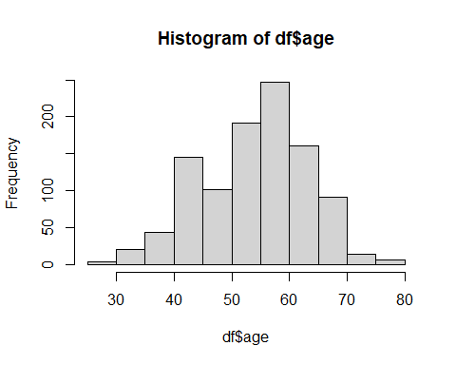
plot(df$sex)
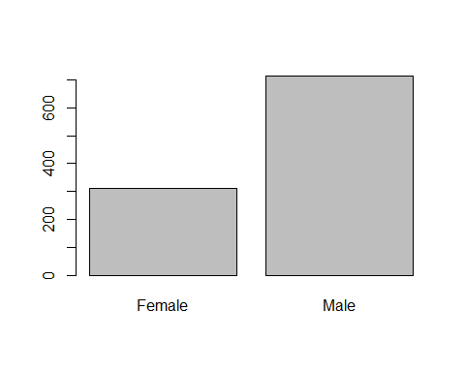
df$age <- as.numeric(df$age)
df$trestbps <- as.numeric(df$trestbps)
df$chol <- as.numeric(df$chol)
df$thalach <- as.numeric(df$thalach)
df$oldpeak <- as.numeric(df$oldpeak)
sapply(df, class)
## age sex cp trestbps chol fbs restecg thalach
## "numeric" "factor" "factor" "numeric" "numeric" "factor" "factor" "numeric"
## exang oldpeak slope ca thal target
## "factor" "numeric" "factor" "integer" "factor" "numeric"

Detection of errors
Upon reviewing the dataframe summary, we identify errors in the attributes "thal" and "ca". Specifically, for "thal", some individuals possess a value of 3, which does not align with the predefined categorical values. Similarly, for "ca", the maximum value observed is 4, whereas it should range from 0 to 3. We then change this values to NA to be treated later.
summary(df)
## age sex cp trestbps
## Min. :29.00 Female:312 Asymptomatic : 77 Min. : 94.0
## 1st Qu.:48.00 Male :713 Atypical Angina :167 1st Qu.:120.0
## Median :56.00 Non-anginal Pain:284 Median :130.0
## Mean :54.43 Typical Angina :497 Mean :131.6
## 3rd Qu.:61.00 3rd Qu.:140.0
## Max. :77.00 Max. :200.0
## chol fbs restecg thalach exang
## Min. :126 <= 120 mg/dL:872 Abnormality:513 Min. : 71.0 No :680
## 1st Qu.:211 > 120 mg/dL :153 Hypertrophy: 15 1st Qu.:132.0 Yes:345
## Median :240 Normal :497 Median :152.0
## Mean :246 Mean :149.1
## 3rd Qu.:275 3rd Qu.:166.0
## Max. :564 Max. :202.0
## oldpeak slope ca thal
## Min. :0.000 Downsloping:469 Min. :0.0000 3 :410
## 1st Qu.:0.000 Flat :482 1st Qu.:0.0000 Fixed Defect : 64
## Median :0.800 Upsloping : 74 Median :0.0000 Normal : 7
## Mean :1.072 Mean :0.7541 Reversible Defect:544
## 3rd Qu.:1.800 3rd Qu.:1.0000
## Max. :6.200 Max. :4.0000
## target
## Min. :0.1000
## 1st Qu.:0.2600
## Median :0.7100
## Mean :0.5364
## 3rd Qu.:0.8100
## Max. :0.9000
df$thal[which(df$thal==3)] <- NA
df$ca[which(df$ca==4)] <- NA
miss_val = sum(is.na(df))
miss_val
## [1] 428
summary(df)
## age sex cp trestbps
## Min. :29.00 Female:312 Asymptomatic : 77 Min. : 94.0
## 1st Qu.:48.00 Male :713 Atypical Angina :167 1st Qu.:120.0
## Median :56.00 Non-anginal Pain:284 Median :130.0
## Mean :54.43 Typical Angina :497 Mean :131.6
## 3rd Qu.:61.00 3rd Qu.:140.0
## Max. :77.00 Max. :200.0
##
## chol fbs restecg thalach exang
## Min. :126 <= 120 mg/dL:872 Abnormality:513 Min. : 71.0 No :680
## 1st Qu.:211 > 120 mg/dL :153 Hypertrophy: 15 1st Qu.:132.0 Yes:345
## Median :240 Normal :497 Median :152.0
## Mean :246 Mean :149.1
## 3rd Qu.:275 3rd Qu.:166.0
## Max. :564 Max. :202.0
##
## oldpeak slope ca thal
## Min. :0.000 Downsloping:469 Min. :0.0000 3 : 0
## 1st Qu.:0.000 Flat :482 1st Qu.:0.0000 Fixed Defect : 64
## Median :0.800 Upsloping : 74 Median :0.0000 Normal : 7
## Mean :1.072 Mean :0.6961 Reversible Defect:544
## 3rd Qu.:1.800 3rd Qu.:1.0000 NA's :410
## Max. :6.200 Max. :3.0000
## NA's :18
## target
## Min. :0.1000
## 1st Qu.:0.2600
## Median :0.7100
## Mean :0.5364
## 3rd Qu.:0.8100
## Max. :0.9000
##

Univariate detection
Here, we plot, for each numeric variable, its boxplot to identify mild and extreme outliers.
outliers <- function(column, name){
sumlist <- summary(column)
q1 <- sumlist[2]
q3 <- sumlist[5]
boxplot(column, main = paste("Boxplot ", name), col = "orange", horizontal = T)
# IQR calculation
iqr <- q3 - q1
# Mild inferior limit:
mild_inf_lim <- sumlist[2]-1.5*iqr
# Extreme inferior limit:
extreme_inf_lim <- sumlist[2]-3*iqr
abline(v=mild_inf_lim, col = "red", lty = 2)
abline(v=extreme_inf_lim, col = "red", lty = 2, lwd = 2)
mild_sup_lim <- sumlist[5]+1.5*iqr
extreme_sup_lim <- sumlist[5]+3*iqr
abline(v=mild_sup_lim, col = "red", lty = 2)
abline(v=extreme_sup_lim, col = "red", lty = 2, lwd = 2)
}
outliers(df$age, "age")
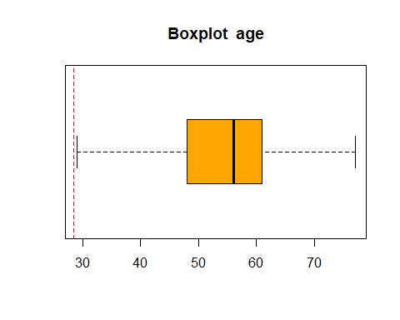
outliers(df$trestbps, "trestbps")
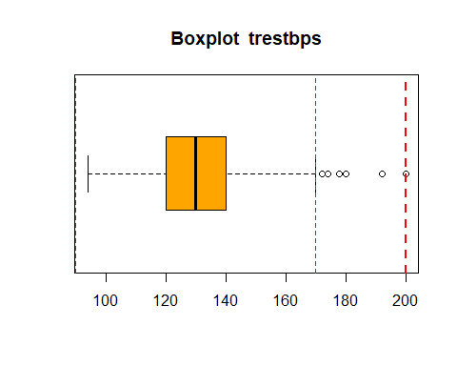
outliers(df$chol, "chol")
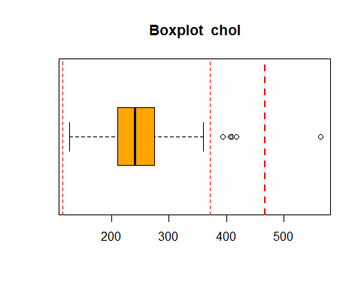
outliers(df$thalach, "thalach")
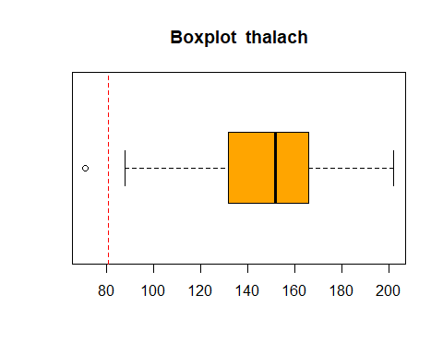
outliers(df$oldpeak, "oldpeak")
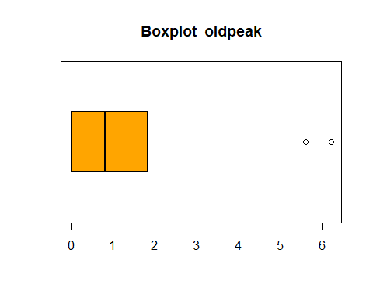
outliers(df$ca, "ca")
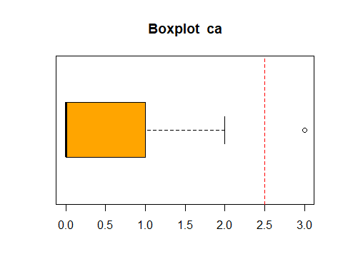
outliers(df$target, "target")
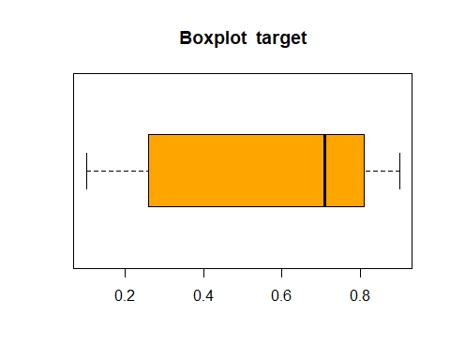
FindMildOutliers <- function(data) {
lowerq = quantile(data, na.rm = TRUE)[2]
upperq = quantile(data, na.rm = TRUE)[4]
iqr = upperq - lowerq #Or use IQR(data)
# we identify extreme outliers
extreme.threshold.upper = (iqr * 1.5) + upperq
extreme.threshold.lower = lowerq - (iqr * 1.5)
result <- which(data > extreme.threshold.upper | data < extreme.threshold.lower)
}
FindExtremeOutliers <- function(data) {
lowerq = quantile(data, na.rm = TRUE)[2]
upperq = quantile(data, na.rm = TRUE)[4]
iqr = upperq - lowerq #Or use IQR(data)
# we identify extreme outliers
extreme.threshold.upper = (iqr * 3) + upperq
extreme.threshold.lower = lowerq - (iqr * 3)
result <- which(data > extreme.threshold.upper | data < extreme.threshold.lower)
}
FindMissingValues <- function(data) {
result <- which(sum(is.na(data)) > 0)
}

Finding all Missing Values by Variables
The dataframe had no missing values. The numbers shown below are the changed errors by NA values, as we’ll treat them as such.
miss <- colSums(is.na(df))
rank_miss <- sort(miss, decreasing = TRUE)
rank_miss
## thal ca age sex cp trestbps chol fbs
## 410 18 0 0 0 0 0 0
## restecg thalach exang oldpeak slope target
## 0 0 0 0 0 0

Finding all Extreme Outliers by Variables
As seen in the boxplots, the only attribute with outliers is “chol”.
df2 <- Filter(is.numeric, df)
pos <- lapply(df2, FindExtremeOutliers)
extr_out <- lengths(pos)
num_outliers = length(pos)
rank_extr <- sort(extr_out, decreasing = TRUE)
rank_extr
## chol age trestbps thalach oldpeak ca target
## 3 0 0 0 0 0 0

Finding all Mild Outliers by Variables
We find the exact number of mild outliers as seen in the boxplots, and rank them.
df2 <- Filter(is.numeric, df)
pos <- lapply(df2, FindMildOutliers)
mild_out <- lengths(pos)
rank_mild <- sort(mild_out, decreasing = TRUE)
rank_mild
## ca trestbps chol oldpeak thalach age target
## 69 30 16 7 4 0 0

Finding all Missing Values by Individuals
pos <- apply(df, 1, FindMissingValues)
pos <- which(pos > 0)
pos
## [1] 1 2 3 4 8 9 12 14 18 26 33 34 39 40 42
## [16] 44 48 50 52 53 54 55 56 57 59 66 70 71 72 74
## [31] 75 78 81 84 90 93 98 102 103 107 108 109 112 113 114
## [46] 116 117 118 121 123 125 129 135 141 146 148 149 152 153 154
## [61] 155 156 157 158 159 164 166 172 175 176 177 180 181 183 186
## [76] 187 189 190 192 193 197 200 203 204 209 210 211 213 217 219
## [91] 222 226 230 231 233 236 238 239 242 243 247 248 253 254 255
## [106] 259 262 267 269 271 272 276 277 279 285 287 290 291 292 295
## [121] 298 302 304 306 311 312 313 315 317 319 323 327 335 336 337
## [136] 340 341 344 347 349 350 352 353 355 362 367 368 369 371 372
## [151] 381 382 383 384 385 392 394 395 397 398 401 405 408 415 418
## [166] 425 426 429 431 432 438 442 443 448 451 453 455 461 464 465
## [181] 466 472 475 476 477 478 480 481 482 483 486 487 488 493 494
## [196] 496 497 507 509 512 516 517 519 520 521 522 524 525 527 529
## [211] 531 539 540 541 546 550 551 553 555 556 557 570 572 575 577
## [226] 580 581 584 585 586 587 589 593 596 598 601 602 611 612 614
## [241] 615 621 622 625 626 627 628 631 635 642 643 644 646 651 654
## [256] 659 668 672 673 674 675 676 677 678 680 682 684 686 688 689
## [271] 691 693 695 696 698 700 702 705 706 707 710 711 712 717 720
## [286] 726 727 728 729 733 737 738 739 740 743 744 748 750 754 763
## [301] 765 766 767 768 769 774 777 778 782 785 786 787 788 790 791
## [316] 792 793 798 799 801 806 809 811 812 814 816 821 823 828 830
## [331] 832 833 834 838 841 843 845 850 853 854 856 860 863 864 873
## [346] 876 877 879 881 883 884 885 886 887 889 890 891 893 895 896
## [361] 897 900 909 910 911 913 916 917 920 921 922 923 926 928 929
## [376] 930 931 932 934 939 941 944 945 946 949 950 952 956 958 963
## [391] 964 967 969 971 972 975 976 980 982 984 985 986 989 992 994
## [406] 995 996 997 998 1000 1004 1006 1008 1010 1011 1013 1016 1018 1019 1022
## [421] 1025

Finding all Extreme Outliers by Individuals
df2 <- Filter(is.numeric, df)
posExtremeInd <- apply(df2, 1, FindExtremeOutliers)
posExtremeInd <- which(posExtremeInd > 0)
posExtremeInd
## [1] 159 193 465

Finding all Mild Outliers by Individuals
df2 <- Filter(is.numeric, df)
pos <- apply(df2, 1, FindMildOutliers)
pos <- which(pos > 0)
pos
## [1] 7 12 63 98 108 114 124 151 155 159 168 180 193 210 212
## [16] 253 256 267 296 329 353 371 372 395 414 423 436 451 465 482
## [31] 486 494 543 547 553 578 579 585 611 642 662 666 675 686 743
## [46] 766 767 778 790 890 959 997 1014 1018
length(pos)
## [1] 54

Create variable adding the total number missing values, outliers and errors.
num_outliers_miss_errors = miss_val + num_outliers
num_outliers_miss_errors
## [1] 435

Compute the correlation with all other variables. Rank these variables according the correlation
library(mvoutlier)
## Warning: package 'mvoutlier' was built under R version 4.3.3
## Loading required package: sgeostat
library(FactoMineR)
df2 <- Filter(is.numeric, df)
res <- cor(df2)
round(res, 2)
## age trestbps chol thalach oldpeak ca target
## age 1.00 0.27 0.22 -0.39 0.21 0.37 -0.22
## trestbps 0.27 1.00 0.13 -0.04 0.19 0.10 -0.14
## chol 0.22 0.13 1.00 -0.02 0.06 0.14 -0.09
## thalach -0.39 -0.04 -0.02 1.00 -0.35 -0.27 0.40
## oldpeak 0.21 0.19 0.06 -0.35 1.00 0.30 -0.40
## ca 0.37 0.10 0.14 -0.27 0.30 1.00 -0.46
## target -0.22 -0.14 -0.09 0.40 -0.40 -0.46 1.00
library(corrplot)
## Warning: package 'corrplot' was built under R version 4.3.3
## corrplot 0.92 loaded
corrplot(res)
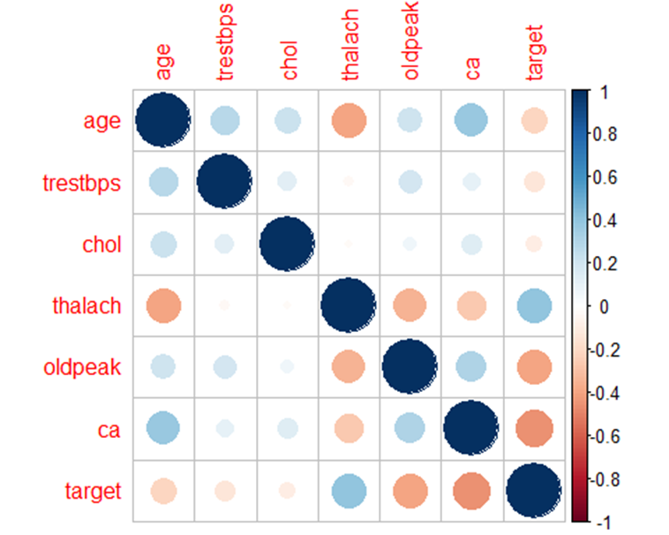

Correlation variable and all other variables
Here, we only show one of the condes, as there are a lot of variables and the information conveyed by each is already interpreted in the text accompanying each "condes/catdes" call.
condes(df, 1)
##
## Link between the variable and the continuous variables (R-square)
## =================================================================================
## correlation p.value
## ca 0.3656041 3.324976e-33
## trestbps 0.2711214 9.961994e-19
## chol 0.2198225 1.107920e-12
## oldpeak 0.2081367 1.704543e-11
## target -0.2159057 2.818627e-12
## thalach -0.3902271 1.273827e-38
##
## Link between the variable and the categorical variable (1-way anova)
## =============================================
## R2 p.value
## slope 0.036974393 4.354455e-09
## restecg 0.033848438 2.281014e-08
## cp 0.036010239 3.672018e-08
## fbs 0.014699981 9.970347e-05
## thal 0.017396555 4.553735e-04
## sex 0.010658559 9.325674e-04
## exang 0.007772782 4.733034e-03
##
## Link between variable and the categories of the categorical variables
## ================================================================
## Estimate p.value
## slope=Flat 1.3706123 2.277933e-08
## cp=Typical Angina 1.6445058 3.400069e-06
## fbs=> 120 mg/dL 1.5425998 9.970347e-05
## thal=NA 1.2583488 4.518687e-04
## sex=Female 1.0172461 9.325674e-04
## exang=Yes 0.8459079 4.733034e-03
## restecg=Hypertrophy 3.7494584 1.660865e-02
## cp=Non-anginal Pain -0.6225968 4.519044e-02
## exang=No -0.8459079 4.733034e-03
## sex=Male -1.0172461 9.325674e-04
## fbs=<= 120 mg/dL -1.5425998 9.970347e-05
## thal=Reversible Defect -1.0466817 4.024544e-05
## cp=Atypical Angina -2.8946935 6.007198e-07
## restecg=Normal -0.3390728 3.650539e-07
## restecg=Abnormality -3.4103856 1.421567e-08
## slope=Downsloping -2.1915443 6.132279e-10
# age & sex -> There is a almosts nonexistent dependance between these two variables, since p-value < 0.05
# age & cp -> There is a almosts nonexistent dependance between these two variables, since p-value < 0.05
# age & trestbps -> There is slight positive correlation between the age and trestbps,since p-value < 0.05
# age & chol -> There is slight positive correlation between the age and chol,since p-value < 0.05
# age & fbs -> There is a slight dependance between these two variables, since p-value < 0.05
# age & restecg -> There is a almosts nonexistent dependance between these two variables, since p-value < 0.05
# age & thalach -> There is a near moderate negative correlation between these variables, since p-value < 0.05
# age & exang -> Exang has no effect on the va lues of age, p-value > 0.05
# age & oldpeak -> There is slight positive correlation between the age and oldpeak ,since p-value < 0.05
# age & slope -> There is a almosts nonexistent dependance between these two variables, since p-value < 0.05
# age & ca -> There is slight positive correlation between the age and ca,since p-value < 0.05
# age & thal -> There is a almosts nonexistent dependance between these two variables, since p-value < 0.05
# age & target -> There is a slight negative correlation between these variables, since p-value < 0.05
#Correlation with sex and all other variables
#catdes(df, 2)
# sex & age -> Age has a no effect in the value of sex, since p-value > 0,05
# sex & cp -> 34.93% of Female have Non-anginal Pain, 42.63% of Female have Typical Angina,
# and 4.17% are Asymptomatic.
# 8.98% of Male are Asymptomatic, 51.05% of Male have Typical Angina, and 24.54%
# of Male have Non-anginal Pain.
# sex & trestbps -> Trestbps has no effect in the value of sex, since p-value > 0,05
# sex & chol -> Chol has a small to medium effect in the value of sex, since p-value < 0,05
# sex & fbs -> Fbs is not significant.
# sex & restecg -> 3.53% of Female have Hypertrophy, and the rest are not significant.
# 0.56% of Male have Hypertrophy, and the rest are not significant.
# sex & thalac -> Thalac is not significant.
# sex & exang -> 76.28% of Female have the value of NO, and the other 23.72% have a value of YES.
# 38.01% of Male have a value of YES, and the other 61.99% have a value of NO.
# sex & oldpeak -> Oldpeak has no effect in the value of sex, since p-value > 0,05
# sex & slope -> Slope is not significant.
# sex & ca -> Ca has a small effect in the value of sex, since p-value < 0,05
# sex & thal -> 80% of Female have Reversible Defect, 1.28% of Female have Fixed Defect
# and 16.99% have no value.
# 50.07% of Male have no value, 8.42% of Male have Fixed Defect, 40.95% of
# Male have Reversible Defect.
# sex & target -> Target has a medium effect in the value of sex, since p-value < 0,05
# Correlation with cp and all other variable
#catdes(df, 3)
#cp & age -> Age has a small effect in the value of cp, since p-value < 0.05
#cp & sex -> 83.11% of Asymptomatic are Male and the other 16.88% are Female.
# Sex has no effect on the people who has Atypical Angina.
# 61.62% of Non-anginal Pain are Male and the other 38.38% are Female.
# 73.24% of Typical Angina are Male and the other 26.76% are Female.
#cp & trestbps -> Trestbps has a medium effect in the value of cp, since p-value < 0.05.
#cp & chol -> Chol has no effect in cp's value, since p-value > 0.05.
#cp & fbs -> Fbs has no effect on the people who is Asymtomatic.
# 90.4% of Atypical Angina has fbs<=120 mg/dL and the other 9.58% has fbs>120 mg/dL.
# 19.36% of Non-anginal Pain has fbs > 120 mg/dL and the other 80.63% has fbs<=120 mg/dL.
# Fbs has no effect on the people who has Typical Angina.
#cp & restecg -> restecg has no effect on the people who is Asymtomatic.
# 61.67% of Atypical Angina has abnormal restecg, 38.32% has normal restecg and the remaining Hypertrophy restecg has no effect.
# 41.19% of Non-anginal Pain has normal restecg, 57.74% has abnormal restecg and the remaining Hypertrophy restecg has no effect.
# 54.32% of Typical Angina has normal restecg, 43.26% has abnormal restecg and the remaining Hypertrophy restecg has no effect.
#cp & thalach -> Thalach has a large effect in the value of cp, since p-value < 0.05
#cp & exang -> 83.11% of Asymptomatic has no exang and the other 16.88% has exang.
# 92.81% of Atypical Angina has no exang and the other 7.18% has exang.
# 86.97% of Non-anginal Pain has no exang and the other 13.02% has exang.
# 56.94% of Typical Angina has exang and the other 43.06% has no exang.
#cp & oldpeak -> Oldpeak has a large effect in the value of cp, since p-value < 0.05
#cp & slope -> slope has no effect on the people who is Asymtomatic.
# 70.66% of Atypical Angina has downsloping slope, 24.55% has flat slope and the remaining Upsloping slope has no effect.
# 55.98% of Non-anginal Pain has downsloping slope, 38.73% has flat slope and the remaining Upsloping slope has no effect.
# 58.75% of Typical Angina has flat slope, 32.79% has downsloping slope and the remaining Upsloping slope has no effect.
#cp & ca -> Ca has a medium effect in the value of cp, since p-value < 0.05
#cp & thal -> thal has no effect on the people who is Asymtomatic.
# thal has no effect on the people who has Atypical Angina.
# 95.07% of Non-anginal Pain has reversible defect thal, 3.87% has fixed defect and the remaining normal thal has no effect.
# 85.51% of Typical Angina has reversible defect thal, 13.68% has fixed defect and the remaining normal thal has no effect.
#cp & target -> Target has a large effect in the value of cp, since p-value < 0.05
#condes(df, 4)
# trestbps & age -> There is slight positive correlation between trestbps and age, since p-value < 0.05
# trestbps & sex -> There is an almost nonexistent dependence between these two variables, since p-value < 0.05
# trestbps & cp -> There is an almost nonexistent dependence between these two variables, since p-value < 0.05
# trestbps & chol -> There is slight positive correlation between the trestbps and chol,since p-value < 0.05
# trestbps & fbs -> There is a slight dependence between these two variables, since p-value < 0.05
# trestbps & restecg -> There is an almost nonexistent dependence between these two variables, since p-value < 0.05
# trestbps & thalach -> Talach has no effect on the values of trestbps, p-value > 0.05
# trestbps & exang -> Exang has no effect on the values of trestbps, p-value > 0.05
# trestbps & oldpeak -> There is slight positive correlation between trestbps and oldpeak ,since p-value < 0.05
# trestbps & slope -> There is an almost nonexistent dependence between these two variables, since p-value < 0.05
# trestbps & ca -> There is slight positive correlation between trestbps and ca,since p-value < 0.05
# trestbps & thal -> There is an almost nonexistent dependence between these two variables, since p-value < 0.05
# trestbps & target -> There is a slight negative correlation between these variables, since p-value < 0.05
# Correlation with chol and all other variable
#condes(df, 5)
#chol & age -> There is a slight positive correlation between the chol and age,since p-value < 0.05
#chol & sex -> There is a almost nonexistent dependence between these two variables, since p-value < 0.05
#chol & cp -> Only the category Typical Angina has a positive (or significant) impact in the mean of chol
#chol & trestbps -> There is a non to a slight positive correlation between these variables, since p-value < 0.05
#chol & fbs -> Fbs is not significant
#chol & restecg -> There is a almost nonexistent dependence between these two variables, since p-value < 0.05
#chol & thalach -> Thalach is not significant
#chol & exang -> There is a almost nonexistent dependence between these two variables, since p-value < 0.05
#chol & oldpeak -> There is a almost nonexistent correlation between these two variables, since p-value < 0.05
#chol & slope -> Only the category Flat has a positive (or significant) impact in the mean of chol
#chol & ca -> There is a almost nonexistent correlation between these two variables, since p-value < 0.05
#chol & thal -> There is a almost nonexistent dependence between these two variables, since p-value < 0.05
#chol & target -> There is a non to slight negative correlation between these two variables, since p-value < 0.05
# Correlation with fbs and all other variable
#catdes(df, 6)
#fbs & age -> Age has a small effect in the value of fbs, since p-value < 0.05.
#fbs & sex -> Sex has no effect on people who has fbs <= 120 mg/dL neither on fbs > 120 mg/dL.
#fbs & cp -> 17.32% of people who has fbs <= 120 mg/dL has Atypical Angina cp, the 26.26% has Non-anginal Pain cp, and the people with Typical Angina and Asymptomatic have no effect on fbs <= 120 mg/dL.
# 35.94% of people who has fbs > 120 mg/dL has Non-anginal Pain cp, the 10.45% has Atypical Angina cp, and the people with Typical Angina and Asymptomatic have no effect on fbs > 120 mg/dL.
#fbs & trestbps -> Trestbps has a small effect in the value of fbs, since p-value < 0.05.
#fbs & chol -> Chol has no effect in values of fbs, since p-value > 0.05.
#fbs & restecg -> 51.83% of people who has fbs <= 120 mg/dL has Abnormality restecg, the 46.44% has Normal restecg and the remaining Hypertrophy restecg has no effect on fbs <= 120 mg/dL.
# 60.13% of people who has fbs > 120 mg/dL has Normal restecg, the 39.87% has Abnormality restecg and the remaining Hypertrophy restecg has no effect on fbs > 120 mg/dL.
#fbs & thalach -> Thalach has no effect in values of fbs, since p-value > 0.05.
#fbs & exang -> Exang has no effect in values of fbs, since p-value > 0.05.
#fbs & oldpeak -> Oldpeak has no effect in values of fbs, since p-value > 0.05.
#fbs & slope -> 6.07% of people who has fbs <= 120 mg/dL has Upsloping slope and the remaining Downsloping slope has no effect on fbs <= 120 mg/dL neither Flat slope.
# 13.72% of people who has fbs > 120 mg/dL has Upsloping slope and the remaining Downsloping slope has no effect on fbs > 120 mg/dL neither Flat slope.
#fbs & ca -> Ca has a small effect in the value of fbs, since p-value < 0.05.
#fbs & thal -> 91.97% of people with fbs >= 120 mg/dL has Reversible Defect thal, the 0.34% has Normal thal and the remaining 7.68% has Fixed Defect thal.
# 21.57% of people with fbs >= 120 mg/dL has Fixed Defect thal, the 2.61% has Normal thal and the remaining 75.82% has Reversible Defect thal.
#fbs & target -> Target has no effect in values of fbs, since p-value > 0.05.
#catdes(df, 7)
#restecg & age -> Age has a small effect in the value of restecg, since p-value < 0.05.
#restecg & sex -> Sex has no effect on the people who have Abnormality.
# 73.33% of people with Hypertrophy are Female and the other 26.66% are Male.
# Sex has no effect on the people considered "Normal".
#restecg & trestbps -> Trestbps has a small effect in the value of restecg, since p-value < 0.05.
#restecg & chol -> Chol has a small effect in restecg value, since p-value > 0.05.
#restecg & fbs -> 88.11% of people with Abnormality has fbs<=120 mg/dL and the other 11.89% has fbs>120 mg/dL
# Fbs has no effect on people who have Hypertrophy.
# 81.48% of people considered "Normal" has fbs<=120 mg/dL and the other 18.52% has fbs>120 mg/dL
#restecg & thalach -> Thalach has a small effect in the value of restecg, since p-value < 0.05.
#restecg & exang -> 70.76% of people with Abnormality have Exang=No and the other 29.24% Exang=Yes.
# Exang has no effect on people who have Hypertrophy.
# 62.37 of people considered "Normal" have Exang=No and the other 37.62% Exang=Yes.
#restecg & oldpeak -> Oldpeak has a small effect in the value of restecg, since p-value < 0.05
#restecg & slope -> 53.60% of people with Abnormality have Downsloping and the other 40.74% Flat slope.
# 26.66% of people with Hypertrophy have Upsloping and the other 73.33% Flat slope.
# 39.03% of people considered "Normal" have Downsloping and 52.71% Flat slope.
#restecg & ca -> Ca has a small effect in the value of restecg, since p-value < 0.05
#restecg & thal -> 7.79% of people with Abnormality have thal=Fixed Defect and the rest has no effect with Abnormality values.
# thal has no effect on people who have Hyperthrophy
# thal has no effect on people considered "normal"
#restecg & target -> Target has a small effect in the value of restecg, since p-value < 0.05
# Correlation with thalac and all other variable
#condes(df, 8)
#thalac & age -> There is a slight negative correlation between the thalac and age,since p-value < 0.05
#thalac & sex -> Sex is not significant
#thalac & cp -> There is a almost nonexistent dependence between these two variables, since p-value < 0.05
#thalac & trestbps -> Trestbps is not significant
#thalac & chol -> Thalach is not significant
#thalac & fbs -> Fbs is not significant
#thalac & restecg -> There is a almost nonexistent dependence between these two variables, since p-value < 0.05
#thalac & exang -> There is a almost nonexistent dependence between these two variables, since p-value < 0.05
#thalac & oldpeak -> There is a slight negative correlation between these two variables, since p-value < 0.05
#thalac & slope -> There is a almost nonexistent dependence between these two variables, since p-value < 0.05
#thalac & ca -> There is a slight negative correlation between these two variables, since p-value < 0.05
#thalac & thal -> There is a almost nonexistent dependence between these two variables, since p-value < 0.05
#thalac & target -> There is a non to slight negative correlation between these two variables, since p-value < 0.05
# Correlation with exang and all other variable
#catdes(df, 9)
# exang & age -> Age has non to small effect in the value of exang, since p-value > 0,05
# exang & sex -> Exang=NO:35.00% are Female, and the other 65.00% are Male.
# Exang=YES: 78.55% are Male, and the other 21.45% are Female.
# exang & cp -> Exang=NO: 36.32% have Non-anginal Pain, 22.79% have Atypical Angina, 9.41% are Asymptomatic, and
# 31.47% have Typical Angina.
# Exang=YES: 82.03% have Typical Angina, 3.77% are Asymptomatic, 3.48% have Atypical Angina, and
# 10.72% have Non-anginal Pain
# exang & trestbps -> Trestbps has no effect in the value of exang, since p-value > 0,05
# exang & chol -> Chol has non to small effect in the value of exang, since p-value < 0,05
# exang & fbs -> Fbs is not significant.
# exang & restecg -> Exang=NO:53.38% have Abnormality, 45.59% are Normal and the rest is not significant.
# Exang=YES:54.2% are Normal, 43.48% have ABnormality and the rest is not significant.
# exang & thalac -> Thalac has a large effect in the value of exang, since p-value < 0,05
# exang & oldpeak -> Oldpeak has medium to large effect in the value of exang, since p-value > 0,05
# exang & slope -> Exang=NO: 56.18% have Downsloping, 37.94% have Flat, and 5.88% have Upsloping
# Exang=YES: 64.93% have Flat, 9.9% have Upsloping, and 25.22% have Downsloping
# exang & ca -> Ca has a small effect in the value of exang, since p-value < 0,05
# exang & thal -> Exang=NO:92.5% have Reversible Defect, 7.05% have Fixed Defect
# and the rest is not significant.
# Exang=YES: 15.07% have Fixed Defect, 83.77% have Reversible Defect and the rest is not significant
# exang & target -> Target has a large effect in the value of exang, since p-value < 0,05
# Correlation with oldpeak and all other variables
#condes(df, 10)
# oldpeak & age -> There is a slight positive correlation between the oldpeak and age ,since p-value < 0.05
# oldpeak & sex -> There is almost nonexistent dependence between these two variables, since p-value < 0.05
# oldpeak & cp -> There is a medium dependence between these two variables, since p-value < 0.05
# oldpeak & trestbps -> There is slight positive correlation between the oldpeak and trestbps,since p-value < 0.05
# oldpeak & chol -> There is slight positive correlation between the oldpeak and chol,since p-value < 0.05
# oldpeak & fbs -> fbs has no effect on the values of oldpeak, since p-value > 0.05
# oldpeak & restecg -> There is a small dependence between these two variables, since p-value < 0.05
# oldpeak & thalach -> There is a near moderate negative correlation between these variables, since p-value < 0.05
# oldpeak & exang -> There is a medium dependence between these two variables, since p-value < 0.05
# oldpeak & slope -> There is a large dependence between these two variables, since p-value < 0.05
# oldpeak & ca -> There is a slight positive correlation between the oldpeak and ca,since p-value < 0.05
# oldpeak & thal -> There is a medium dependence between these two variables, since p-value < 0.05
# oldpeak & target -> There is a near moderate negative correlation between these variables, since p-value < 0.05
# Correlation with slope and all other variable
#catdes(df, 11)
#slope & age -> Age has a small effect in values of slope, since p-value < 0.05 and eta2 < 0.06 and eta2 > 0.01.
#slope & sex -> Sex has no effect in values of slope, since p-value > 0.05.
#slope & cp -> 25.16% of Downsloping slope has Atypical Angina cp, 33.90% has Non-anginal Pain, 34.75% has Typical Angina and the remaining Asymptomatic values have no effect in Downsloping slope.
# 8.51% of Flat slope has Atypical Angina cp, 22.82% has Non-anginal Pain, 60.58% has Typical Angina and the remaining Asymptomatic values have no effect in Flat slope.
# Cp has no effect in values of Upsloping slope.
#slope & trestbps -> Trestbps has a small effect in values of slope, since p-value < 0.05 and eta2 < 0.06.
#slope & chol -> Chol has no effect in values of slope
#slope & fbs -> fbs has no effect in values of Downsloping slope.
# fbs has no effect in values of Flat slope.
# 28.38% of Upsloping slope values have fbs > 120 mg/dL and the remaining 71.62% have fbs <= 120 mg/dL.
#slope & restecg -> 58.64% of Downsloping slope values have Abnormality restecg, 41.36% have Normal restecg and 0% have Hypertrophy restecg.
# 54.36% of Flat slope values have Normal restecg, 43.36% have Abnormality restecg and 2.28% have Hypertrophy restecg.
# 5.40% of Uplsoping values have Hypertrophy restecg, and Normal restecg neither Abnormality restecg have effect in values of Upsloping slope.
#slope & thalach -> thalach has a large effect in values of slope, since p-value < 0.05 and eta2 > 0.14.
#slope & exang -> 81.45% of Downsloping slope values have no exang and 18.55% have exang.
# 53.53% of Flat slope values have no exang and 46.47% have exang.
# 54.05% of Upsloping slope values have no exang and 45.94% have exang.
#slope & oldpeak -> oldpeak has a large effect in values of slope, since p-value < 0.05 and eta2 > 0.14.
#slope & ca -> Ca has a small effect in values of slope, since p-value < 0.05 and eta2 < 0.06.
#slope & thal -> 97.87% of Downsloping slope values have Reversible Defect thal, 1.49% have Fixed Defect thal and Normal thal has no effect in Downsloping.
# Thal has no effect in Flat slope values.
# 36.48% of Upsloping slope values have Reversible Defect thal, 63.51% have Fixed Defect thal and Normal thal has no effect in Upsloping.
#slope & target -> Target has a medium effect in values of slope, since p-value < 0.05 and eta2 < 0.14 and eta2 > 0.06.
# Correlation with ca and all other variables
#condes(df, 12)
# ca & age -> There is a slight positive correlation between the ca and age ,since p-value < 0.05
# ca & sex -> There is a small dependence between these two variables, since p-value < 0.05
# ca & cp -> There is a small dependence between these two variables, since p-value < 0.05
# ca & trestbps -> There is slight positive correlation between the ca and trestbps,since p-value < 0.05
# ca & chol -> There is slight positive correlation between the ca and chol,since p-value < 0.05
# ca & fbs -> There is a small dependence between these two variables, since p-value < 0.05
# ca & restecg -> There is a small dependence between these two variables, since p-value < 0.05
# ca & thalach -> There is a slight negative correlation between these variables, since p-value < 0.05
# ca & exang -> There is a small dependence between these two variables, since p-value < 0.05
# ca & oldpeak -> There is a slight positive correlation between the ca and oldpeak,since p-value < 0.05
# ca & slope ->There is a small dependence between these two variables, since p-value < 0.05
# ca & thal -> There is a small dependence between these two variables, since p-value < 0.05
# ca & target -> There is a near moderate negative correlation correlation between these variables, since p-value < 0.05
#catdes(df, 13)
#thal & age -> Age has no effect in the value of thal, since p-value > 0.05.
#thal & sex -> 89% of people with thal=Fixed Defect are Male and the other 11% are Female.
# Sex has no effect on the people with thal=Normal.
# 32.46% of people with thal=Reversible Defect are Female and the other 67.54% are Male.
#thal & trestbps -> Trestbps has a small effect in the value of thal, since p-value < 0.05.
#thal & chol -> Chol has a small effect in thal value, since p-value > 0.05.
#thal & fbs -> 33% of people with thal=Fixed Defect has fbs>=120 mg/dL and the other 67% has fbs>120 mg/dL
# 57.14% of people with thal=Normal has fbs>=120 mg/dL and the other 42.85% has fbs>120 mg/dL
# 12.63% of people with thal=Reversible Defect has fbs<=120 mg/dL and the other 87.36% has fbs>120 mg/dL
#thal & thalach -> Thalach has a small effect in the value of thal, since p-value < 0.05.
#thal & exang -> 48% of people with thal=fixed defect have Exang=No and the other 52% Exang=Yes.
# Exang has no effect on people with thal=Normal
# 68.51% of people with thal=Reversible Defect have Exang=No and the other 31.48% Exang=Yes.
#thal & oldpeak -> Oldpeak has a medium effect in the value of thal, since p-value < 0.05
#thal & slope -> 7% of people with thal=Fixed Defect have Downsloping and the other 47% Flat slope.
# slope has no effect on people with thal=Normal
# 50% of people with thal=Reversible Defect have Downsloping and 2.94% Flat slope.
#thal & ca -> ca has no effect in the value of thal, since p-value > 0.05
#thal & restecg -> 40% of people with thal=Fixed Defect have Abnormality
# And the rest has no effect with thal values.
#thal & target -> Target has a small effect in the value of thal, since p-value < 0.05

Imputation of factor thal.
library(missMDA)
## Warning: package 'missMDA' was built under R version 4.3.2
# Categorical imputation
f <- Filter(is.factor, df)
vars_dis = colnames(f)
summary(df[,vars_dis])
## sex cp fbs restecg
## Female:312 Asymptomatic : 77 <= 120 mg/dL:872 Abnormality:513
## Male :713 Atypical Angina :167 > 120 mg/dL :153 Hypertrophy: 15
## Non-anginal Pain:284 Normal :497
## Typical Angina :497
##
## exang slope thal
## No :680 Downsloping:469 3 : 0
## Yes:345 Flat :482 Fixed Defect : 64
## Upsloping : 74 Normal : 7
## Reversible Defect:544
## NA's :410
res.input<-imputeMCA(df[,vars_dis],method="EM")
summary(res.input$completeObs)
## sex cp fbs restecg
## Female:312 Asymptomatic : 77 <= 120 mg/dL:872 Abnormality:513
## Male :713 Atypical Angina :167 > 120 mg/dL :153 Hypertrophy: 15
## Non-anginal Pain:284 Normal :497
## Typical Angina :497
## exang slope thal
## No :680 Downsloping:469 Fixed Defect : 82
## Yes:345 Flat :482 Normal : 7
## Upsloping : 74 Reversible Defect:936
##
# Validation
barplot(table(df$thal),col="red")
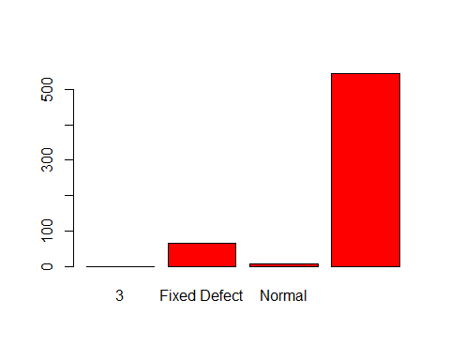
barplot(table(res.input$completeObs[,1]),col="blue")
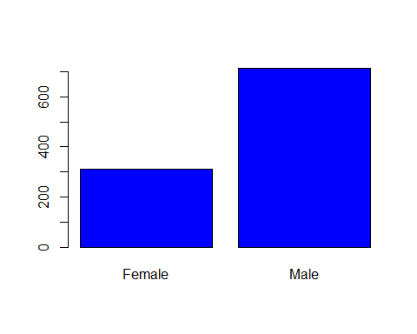
df[,vars_dis] <- res.input$completeObs
summary(df)
## age sex cp trestbps
## Min. :29.00 Female:312 Asymptomatic : 77 Min. : 94.0
## 1st Qu.:48.00 Male :713 Atypical Angina :167 1st Qu.:120.0
## Median :56.00 Non-anginal Pain:284 Median :130.0
## Mean :54.43 Typical Angina :497 Mean :131.6
## 3rd Qu.:61.00 3rd Qu.:140.0
## Max. :77.00 Max. :200.0
##
## chol fbs restecg thalach exang
## Min. :126 <= 120 mg/dL:872 Abnormality:513 Min. : 71.0 No :680
## 1st Qu.:211 > 120 mg/dL :153 Hypertrophy: 15 1st Qu.:132.0 Yes:345
## Median :240 Normal :497 Median :152.0
## Mean :246 Mean :149.1
## 3rd Qu.:275 3rd Qu.:166.0
## Max. :564 Max. :202.0
##
## oldpeak slope ca thal
## Min. :0.000 Downsloping:469 Min. :0.0000 Fixed Defect : 82
## 1st Qu.:0.000 Flat :482 1st Qu.:0.0000 Normal : 7
## Median :0.800 Upsloping : 74 Median :0.0000 Reversible Defect:936
## Mean :1.072 Mean :0.6961
## 3rd Qu.:1.800 3rd Qu.:1.0000
## Max. :6.200 Max. :3.0000
## NA's :18
## target
## Min. :0.1000
## 1st Qu.:0.2600
## Median :0.7100
## Mean :0.5364
## 3rd Qu.:0.8100
## Max. :0.9000
##
miss_val = sum(is.na(df))
miss_val
## [1] 18

Imputation of numeric ca.
library(class)
# Numeric imputation only explanatory variables - never for target
n <- Filter(is.numeric, df)
summary(n)
## age trestbps chol thalach oldpeak
## Min. :29.00 Min. : 94.0 Min. :126 Min. : 71.0 Min. :0.000
## 1st Qu.:48.00 1st Qu.:120.0 1st Qu.:211 1st Qu.:132.0 1st Qu.:0.000
## Median :56.00 Median :130.0 Median :240 Median :152.0 Median :0.800
## Mean :54.43 Mean :131.6 Mean :246 Mean :149.1 Mean :1.072
## 3rd Qu.:61.00 3rd Qu.:140.0 3rd Qu.:275 3rd Qu.:166.0 3rd Qu.:1.800
## Max. :77.00 Max. :200.0 Max. :564 Max. :202.0 Max. :6.200
##
## ca target
## Min. :0.0000 Min. :0.1000
## 1st Qu.:0.0000 1st Qu.:0.2600
## Median :0.0000 Median :0.7100
## Mean :0.6961 Mean :0.5364
## 3rd Qu.:1.0000 3rd Qu.:0.8100
## Max. :3.0000 Max. :0.9000
## NA's :18
vars_con = colnames(n)
fullvariables <- c(1,4,5,8,10,14)
aux <- df[,fullvariables]
dim(aux)
## [1] 1025 6
names(aux)
## [1] "age" "trestbps" "chol" "thalach" "oldpeak" "target"
summary(df)
## age sex cp trestbps
## Min. :29.00 Female:312 Asymptomatic : 77 Min. : 94.0
## 1st Qu.:48.00 Male :713 Atypical Angina :167 1st Qu.:120.0
## Median :56.00 Non-anginal Pain:284 Median :130.0
## Mean :54.43 Typical Angina :497 Mean :131.6
## 3rd Qu.:61.00 3rd Qu.:140.0
## Max. :77.00 Max. :200.0
##
## chol fbs restecg thalach exang
## Min. :126 <= 120 mg/dL:872 Abnormality:513 Min. : 71.0 No :680
## 1st Qu.:211 > 120 mg/dL :153 Hypertrophy: 15 1st Qu.:132.0 Yes:345
## Median :240 Normal :497 Median :152.0
## Mean :246 Mean :149.1
## 3rd Qu.:275 3rd Qu.:166.0
## Max. :564 Max. :202.0
##
## oldpeak slope ca thal
## Min. :0.000 Downsloping:469 Min. :0.0000 Fixed Defect : 82
## 1st Qu.:0.000 Flat :482 1st Qu.:0.0000 Normal : 7
## Median :0.800 Upsloping : 74 Median :0.0000 Reversible Defect:936
## Mean :1.072 Mean :0.6961
## 3rd Qu.:1.800 3rd Qu.:1.0000
## Max. :6.200 Max. :3.0000
## NA's :18
## target
## Min. :0.1000
## 1st Qu.:0.2600
## Median :0.7100
## Mean :0.5364
## 3rd Qu.:0.8100
## Max. :0.9000
##
aux1 <- aux[!is.na(df$ca),]
dim(aux1)
## [1] 1007 6
aux2 <- aux[is.na(df$ca),]
dim(aux2)
## [1] 18 6
knn.ing = knn(aux1, aux2, df$ca[!is.na(df$ca)])
df$ca[is.na(df$ca)] <- as.numeric(as.character(knn.ing))
# Validation
summary(df)
## age sex cp trestbps
## Min. :29.00 Female:312 Asymptomatic : 77 Min. : 94.0
## 1st Qu.:48.00 Male :713 Atypical Angina :167 1st Qu.:120.0
## Median :56.00 Non-anginal Pain:284 Median :130.0
## Mean :54.43 Typical Angina :497 Mean :131.6
## 3rd Qu.:61.00 3rd Qu.:140.0
## Max. :77.00 Max. :200.0
## chol fbs restecg thalach exang
## Min. :126 <= 120 mg/dL:872 Abnormality:513 Min. : 71.0 No :680
## 1st Qu.:211 > 120 mg/dL :153 Hypertrophy: 15 1st Qu.:132.0 Yes:345
## Median :240 Normal :497 Median :152.0
## Mean :246 Mean :149.1
## 3rd Qu.:275 3rd Qu.:166.0
## Max. :564 Max. :202.0
## oldpeak slope ca thal
## Min. :0.000 Downsloping:469 Min. :0.0000 Fixed Defect : 82
## 1st Qu.:0.000 Flat :482 1st Qu.:0.0000 Normal : 7
## Median :0.800 Upsloping : 74 Median :0.0000 Reversible Defect:936
## Mean :1.072 Mean :0.6878
## 3rd Qu.:1.800 3rd Qu.:1.0000
## Max. :6.200 Max. :3.0000
## target
## Min. :0.1000
## 1st Qu.:0.2600
## Median :0.7100
## Mean :0.5364
## 3rd Qu.:0.8100
## Max. :0.9000
miss_val = sum(is.na(df))
miss_val
## [1] 0

Heat Map correlations
df2 <- Filter(is.numeric, df)
df2 <- scale(df2)
cormat <- round(cor(df2),2)
library(reshape2)
melted_cormat <- melt(cormat)
library(ggplot2)
## Warning: package 'ggplot2' was built under R version 4.3.2
ggplot(data = melted_cormat, aes(x=Var1, y=Var2, fill=value)) +
geom_tile()
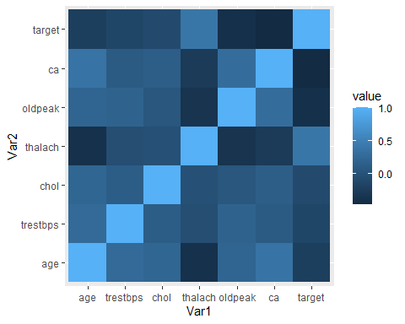

Profiling
We now proceed to do the profiling. As we have a numeric target “target” and numeric and categorical explicative variables, we’ll use the condes tool that provides us with information about the relationships between the indicated variables and the target.
# Continuous output:
library(FactoMineR)
summary(df$target)
## Min. 1st Qu. Median Mean 3rd Qu. Max.
## 0.1000 0.2600 0.7100 0.5364 0.8100 0.9000
res.condes <- condes(df, 14, proba = 0.50)
res.condes$quanti # Global association to numeric variables
## correlation p.value
## thalach 0.39937441 1.564500e-40
## chol -0.09378816 2.650143e-03
## trestbps -0.13566217 1.311535e-05
## age -0.21590573 2.818627e-12
## oldpeak -0.39601538 7.998564e-40
## ca -0.45504567 1.573337e-53
res.condes$quali # Partial association of numeric variables to levels of outcome factor
## R2 p.value
## cp 0.253890752 1.499596e-64
## exang 0.170849731 1.443650e-43
## slope 0.132703531 2.532984e-32
## sex 0.076369394 2.008368e-19
## restecg 0.035701748 8.550961e-09
## thal 0.022665084 8.169298e-06
## fbs 0.001373824 2.357714e-01
res.condes$category # Partial association to significative levels in factors
## Estimate p.value
## exang=No 0.124945652 1.443650e-43
## slope=Downsloping 0.124020359 7.009225e-33
## cp=Non-anginal Pain 0.084617565 4.199338e-24
## sex=Female 0.085785841 2.008368e-19
## cp=Atypical Angina 0.102081089 1.001772e-15
## restecg=Abnormality 0.098801024 2.329818e-09
## thal=Reversible Defect 0.058303056 3.008745e-06
## cp=Asymptomatic 0.018271306 1.491150e-02
## fbs=<= 120 mg/dL 0.014857288 2.357714e-01
## fbs=> 120 mg/dL -0.014857288 2.357714e-01
## slope=Upsloping -0.033533954 1.569582e-01
## restecg=Hypertrophy -0.094438742 5.527308e-02
## thal=Fixed Defect -0.100275222 1.303146e-06
## restecg=Normal -0.004362283 3.705541e-08
## sex=Male -0.085785841 2.008368e-19
## slope=Flat -0.090486405 1.106168e-28
## exang=Yes -0.124945652 1.443650e-43
## cp=Typical Angina -0.204969960 9.699236e-66

Multivariate outliers
library(chemometrics)
## Warning: package 'chemometrics' was built under R version 4.3.3
## Loading required package: rpart
## Warning: package 'rpart' was built under R version 4.3.2
summary(df[,vars_con])
## age trestbps chol thalach oldpeak
## Min. :29.00 Min. : 94.0 Min. :126 Min. : 71.0 Min. :0.000
## 1st Qu.:48.00 1st Qu.:120.0 1st Qu.:211 1st Qu.:132.0 1st Qu.:0.000
## Median :56.00 Median :130.0 Median :240 Median :152.0 Median :0.800
## Mean :54.43 Mean :131.6 Mean :246 Mean :149.1 Mean :1.072
## 3rd Qu.:61.00 3rd Qu.:140.0 3rd Qu.:275 3rd Qu.:166.0 3rd Qu.:1.800
## Max. :77.00 Max. :200.0 Max. :564 Max. :202.0 Max. :6.200
## ca target
## Min. :0.0000 Min. :0.1000
## 1st Qu.:0.0000 1st Qu.:0.2600
## Median :0.0000 Median :0.7100
## Mean :0.6878 Mean :0.5364
## 3rd Qu.:1.0000 3rd Qu.:0.8100
## Max. :3.0000 Max. :0.9000
mout<-Moutlier(df[,vars_con[1:5]],quantile = 0.9975, plot = TRUE)
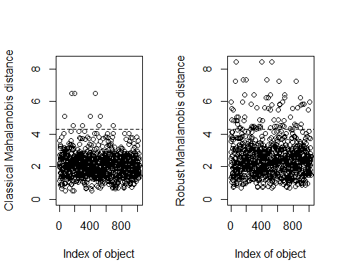
# Classical: Assumption of normality on the underlying generating mechanism
# Robust: Median and absolute median deviations -> Not normal generating mechanism
length(which(mout$rd>mout$cutoff))
## [1] 83
ll<-which(mout$rd>mout$cutoff)
Boxplot(mout$rd)
## [1] 70 394 527 159 193 465 55 56 614 834
df[ll,c(vars_con)]
## age trestbps chol thalach oldpeak ca target
## 7 58 114 318 140 4.4 3 0.37
## 12 43 132 341 136 3.0 0 0.21
## 14 51 140 298 122 4.2 3 0.37
## 30 55 180 327 117 3.4 0 0.26
## 36 46 150 231 147 3.6 0 0.39
## 55 55 140 217 111 5.6 0 0.22
## 56 55 140 217 111 5.6 0 0.35
## 70 62 160 164 145 6.2 3 0.32
## 71 59 170 326 140 3.4 0 0.32
## 78 63 140 187 144 4.0 2 0.28
## 83 46 150 231 147 3.6 0 0.37
## 89 62 140 268 160 3.6 2 0.35
## 93 63 140 187 144 4.0 2 0.22
## 114 57 110 335 143 3.0 1 0.14
## 125 61 120 260 140 3.6 1 0.31
## 151 58 114 318 140 4.4 3 0.12
## 152 54 192 283 195 0.0 1 0.15
## 159 67 115 564 160 1.6 0 0.83
## 166 59 170 326 140 3.4 0 0.11
## 176 56 200 288 133 4.0 2 0.12
## 181 63 140 187 144 4.0 2 0.26
## 193 67 115 564 160 1.6 0 0.89
## 247 54 192 283 195 0.0 1 0.20
## 259 38 120 231 182 3.8 0 0.30
## 268 67 120 237 71 1.0 0 0.13
## 269 58 132 224 173 3.2 2 0.20
## 285 58 132 224 173 3.2 2 0.15
## 295 56 200 288 133 4.0 2 0.23
## 297 67 120 237 71 1.0 0 0.33
## 311 61 120 260 140 3.6 1 0.21
## 327 54 192 283 195 0.0 1 0.33
## 333 37 130 250 187 3.5 0 0.89
## 353 57 110 335 143 3.0 1 0.21
## 357 59 164 176 90 1.0 2 0.19
## 371 43 132 341 136 3.0 0 0.34
## 379 67 120 237 71 1.0 0 0.14
## 382 58 132 224 173 3.2 2 0.14
## 394 62 160 164 145 6.2 3 0.22
## 410 46 150 231 147 3.6 0 0.28
## 434 37 130 250 187 3.5 0 0.70
## 451 63 150 407 154 4.0 3 0.23
## 465 67 115 564 160 1.6 0 0.86
## 482 63 150 407 154 4.0 3 0.39
## 483 51 140 298 122 4.2 3 0.26
## 507 61 120 260 140 3.6 1 0.18
## 509 56 200 288 133 4.0 2 0.36
## 510 55 180 327 117 3.4 0 0.36
## 527 62 160 164 145 6.2 3 0.26
## 529 59 178 270 145 4.2 0 0.85
## 553 43 132 341 136 3.0 0 0.38
## 560 67 120 237 71 1.0 0 0.37
## 588 59 164 176 90 1.0 2 0.16
## 610 55 180 327 117 3.4 0 0.39
## 611 43 132 341 136 3.0 0 0.30
## 614 55 140 217 111 5.6 0 0.33
## 625 59 178 270 145 4.2 0 0.79
## 627 58 132 224 173 3.2 2 0.16
## 628 38 120 231 182 3.8 0 0.22
## 634 61 138 166 125 3.6 1 0.18
## 661 61 138 166 125 3.6 1 0.11
## 662 58 114 318 140 4.4 3 0.36
## 682 59 170 326 140 3.4 0 0.39
## 683 59 164 176 90 1.0 2 0.16
## 686 63 150 407 154 4.0 3 0.13
## 689 56 200 288 133 4.0 2 0.27
## 765 63 140 187 144 4.0 2 0.39
## 766 57 110 335 143 3.0 1 0.35
## 767 57 110 335 143 3.0 1 0.27
## 788 51 140 298 122 4.2 3 0.14
## 813 62 140 268 160 3.6 2 0.25
## 822 62 140 268 160 3.6 2 0.39
## 825 61 138 166 125 3.6 1 0.27
## 834 55 140 217 111 5.6 0 0.40
## 848 61 138 166 125 3.6 1 0.28
## 852 37 130 250 187 3.5 0 0.80
## 887 61 120 260 140 3.6 1 0.33
## 890 63 150 407 154 4.0 3 0.19
## 897 59 178 270 145 4.2 0 0.80
## 903 62 140 268 160 3.6 2 0.35
## 920 38 120 231 182 3.8 0 0.21
## 934 38 120 231 182 3.8 0 0.28
## 987 55 180 327 117 3.4 0 0.20
## 1014 58 114 318 140 4.4 3 0.36
df$mout <- 0
df$mout[ ll ]<-1
df$mout <- factor( df$mout, labels=c( "NoMOut","YesMOut")) #We identify the Mildoutliers if the row has the value "YesMOut" in the mout column.
table(df$mout)
##
## NoMOut YesMOut
## 942 83
